**735/1**

**GEOMETRICAL**

**DRAWING**

**PAPER 1**

**JULY/AUGUST**

**3 HOURS**



**ELITE EXAMINATION BUREAU MOCK 2019**

**Uganda Certificate of Education**

**GEOMETRICAL DRAWING**

**PAPER 1**

3 HOURS

**INSTRUCTIONS TO CANDIDATES:**

* *This paper consists of TWO sections A and B.*
* *Answer four (4) questions two questions from each section.*
* *All questions carry equal marks.*
* *A sheet of drawing paper, size A2 is provided. Use both sides of the drawing paper.*
* *Drawings are not to scale*
* *Unless otherwise stated in the question, strictly geometrical methods must be used.*
* *But lines which are parallel, perpendicular, or inclined at angles of 30****0****, 45****0****, 60****0*** *to other lines which may be drawn without using constructional methods.*
* *All dimensions of the figures are in millimetres.*
* *Unless otherwise stated, solutions are to be in drawn full size.*
* *No dimensions are required on any solution unless specifically requested.*
* *Write your name and examination number at the bottom right-hand corner of your paper.*

**SECTION A:**

**(PLANE GEOMETRY)**

1. a) The 30mm mark on a dipstick for measuring the contents of oil in a tank represents three quarters of a liter.

Design your own dipstick in form of a diagonal scale for measuring up to 4 ½ liters of the content of the container.

b) Construct the shape given below and construct a similar figure with its area reduced by a half.

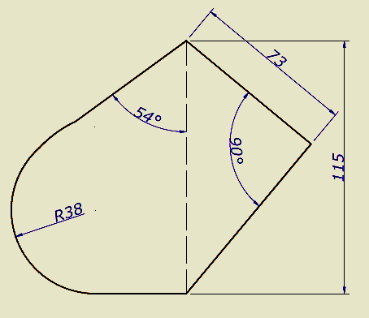

2. a) Draw a circle to touch the circles shown in the figure below.

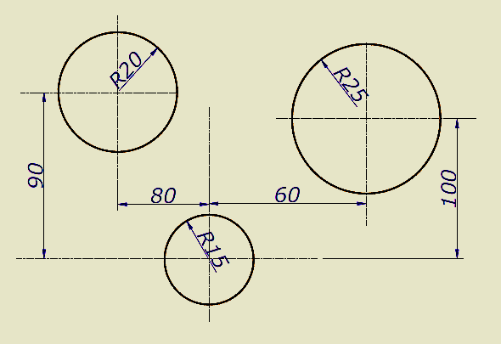

b) Construct a circle to pass through both P and Q and touch the given circle shown in the figure below. Measure and state the diameter of the circle.

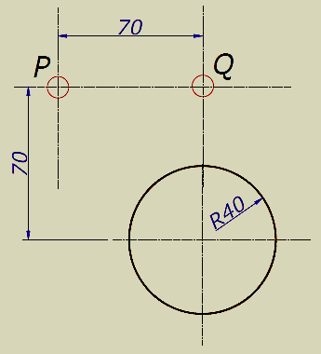

3. The crank **OA** of the mechanism shown below rotates about **O** clockwise. The end **N** of the link **AN** moves along the line **XY** and **SR** swings about **S**.

Construct the locus of **T** and **M** for one complete revolution of crank **OA**.

**OA = 40mm**

**AN = 150mm**

**NM = 65mm**

**MR = 130mm**

**RT = RS = 75mm**

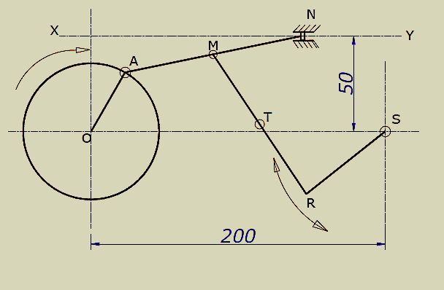

4. Figure below shows a cone rotating in a clockwise direction with point S and T moving at a constant speed to point A in one revolution. Plot the path followed by point T and S on the surface of the cone on both the front elevation and the plan.

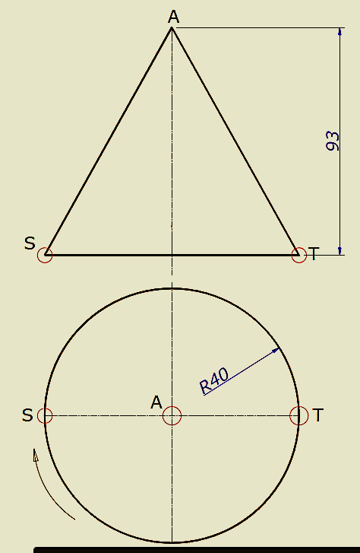

**SECTION B:**

**(SOLID GEOMETRY)**

5. The figure below shows the elevation of a hexagonal based pyramid being interpenetrated by a rectangular based prism.

a) Construct the given front elevation and the plan showing clearly the lines of interpenetration.

b) Construct the development of the pyramid after interpenetration.

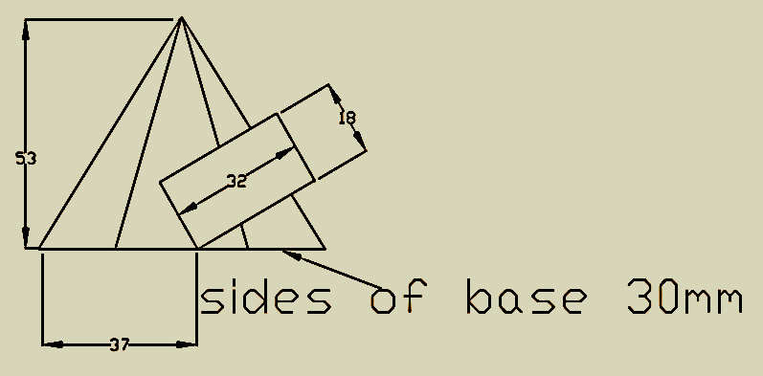

6. Figure below shows a block; construct its auxiliary front elevation on X1 – Y1.

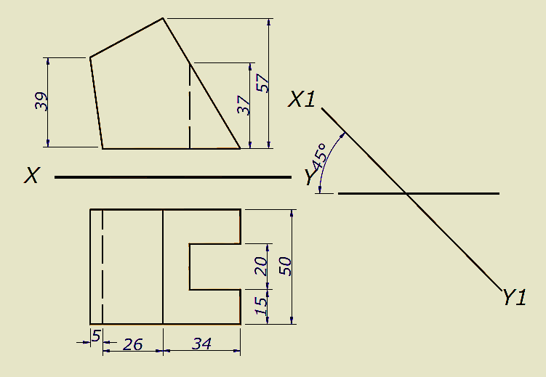

7. Figure below shows a block in orthographic projection. Reconstruct it in isometric projection.

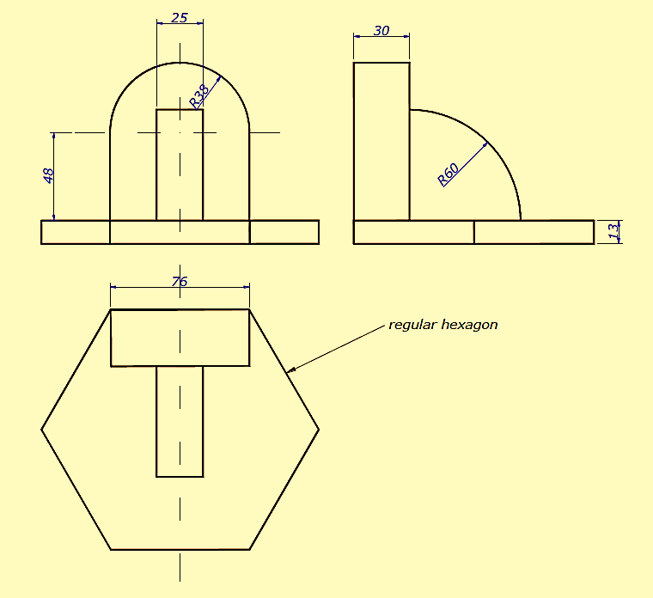

8. The figure below shows a cylinder and a cone in interpenetration.

a) Show the curve of interpenetration.

b) Development of the cylinder after interpenetration.

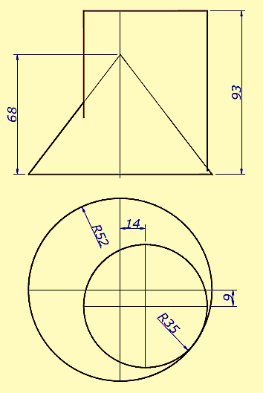

**END**